Material 2 zu S16GW5A02

M2 – Liste der Top 10 und Unteren 10 (Tabelle)

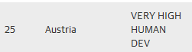
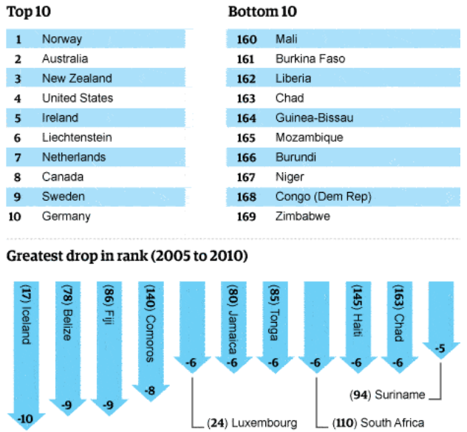
Tabelle 1: Ranking der Länder (Glennie 2010:o.S.)

Glennie, J. (2010): Human development index: Equality matters if we are to reduce poverty. <http://www.theguardian.com/global-development/datablog/2010/nov/04/human-development-index-equality-matters> (Zugriff: 2015-01-02).
© 2015 Guardian News and Media Limited or its affiliated companies. All rights reserved.

